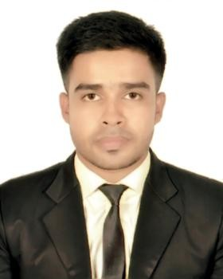
CURRICULUM VITAE

Of
MD. MAMUN RAHMAN
Cell: 01755-000436, 01882-885591

E-mail: minhajulislam81848@gmail.com

CAREER SUMMARY
A job in a challenging & competitive environment in any field, where the dignity of work provides job satisfaction and the place of work provides potential avenues for learning, growing, and achievement of the organization.

WORKING EXPERIENCE

Company : Colombia Washing Plant Ltd
Department : Wash Production
Designation : Sr. Operator
Duration : 02 Year
Company : AR Wet Process Ltd.
Department : R&D Sample
Designation : Sample Technician
Duration : 2 Years
Company : AL Muslim Washing Ltd.
Department : Initial Sample
Designation : Supervisor
Duration : 3 Years till now
COMPUTER & LANGUAGE SKILL
- Skill in MS Office Programs & Internet Applications.
- I am fluent in both English and Bangle Language.
- MS Excel. MS Word

ACADEMIC PROFILE

🞖 S.S.C (Secondary School Certificate)
- Institution : Ambari High School
- Group : Science.
- Year of Passing : 2017
- Board : Dinajpur
- Result : GPA- 3.95 (Out of 5.00)

🞖 (Diploma Engineering Certificate)
- Institution : Upashahar Textile Engineering Institute, Dinajpur.
- Group : Diploma in Textile Engineering
- Year of Passing : 2021
- Board : Bangladesh Technical Education Board
- Result : GPA- 3.51 (Out of 4.00)

PERSONAL INFORMATION
Name : Md Mamun Rahman
Father’s Name : Md Mahabur Rahman
Mother’s Name : Minara Begum
Present Address : Amtola, Kathgora, Asulia, Savar, Dhaka
Permanent Address : Shibkuri, Amtoli, Chirirbandar, Dinajpur
Date of Birth : 14/07/2002
Marital Status : Unmrried
Gender : Male
Religion : Islam
Height : 5’6”
Weight : 60.Kg
NID NO : 6463357068
Nationality : Bangladeshi

Date:………….. Signature:

Md Mamun Rahman

